**Experiment 3**

**Aim:** Design an Obstacle detector and distance measuring device.

**Apparatus:** Breadboard, Arduino, Resistances (220 ohm), Jumper wires, Ultrasonic sensor, LED.

**Circuit Diagram:**

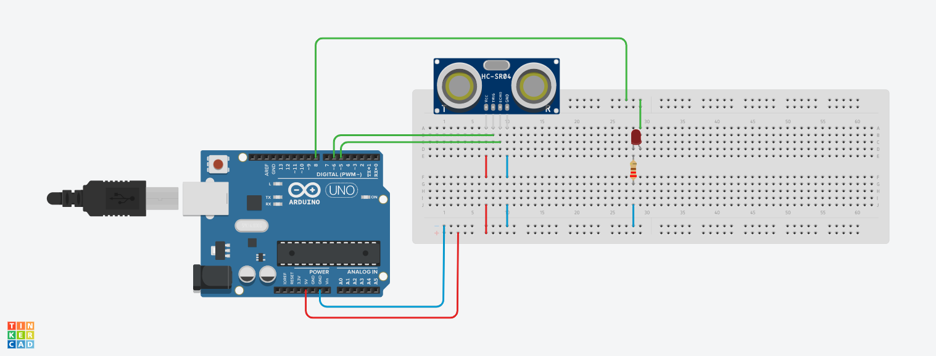

**Theory:**

1. Concept Used:
2. In Arduino, digital pins provide input as well as output but analog pins only provide input.
3. Current flows from anode to cathode and not in reverse direction through LEDs.
4. Sound waves deflect back on striking an object in its path.
5. Time gap between sending signal and receiving echo is 10 microseconds.
6. Learning & Observations:
7. Trig pin of ultrasonic sensor receives signal from Arduino.
8. Echo pin of ultrasonic sensor gives signal to Arduino.
9. Learn how to use Arduino with ultrasonic sensor.
10. When echo pin gives signal to Arduino then it records time and find distance travelled.

**Problems and Troubleshooting:**

1. Using if condition to make a obstacle detection. On applying different conditions we come to know how to use it.
2. Some error in program code. By compiling it and correct the incorrect lines.

**Precautions:**

1. Connections should be made carefully and clearly.
2. Use resistance in series with LED so excess current does not damage LED.
3. Right connection of trig and echo pin of ultrasonic sensor with Arduino.
4. Using “if-else” carefully.
5. Use right commands for serial monitor to store, show readings.

**Learning Outcomes:**

1. Using Arduino and defining output pins.
2. Speed of sound is 340 m/s.
3. Using void setup and void loop.
4. Operating frequency of ultrasonic sensor is 40 KHz.
5. Using Serial monitor and print on serial monitor.

**Result:** Obstacle detector and distance measuring device worked properly on running with Arduino.